Tanzania

## Population Data

The data set shows the political stability estimate of the country each year.

## # A tibble: 23 x 5  
## country iso3c date population popCategory5  
## <chr> <chr> <dbl> <dbl> <chr>   
## 1 Tanzania TZA 1996 30444526 medium   
## 2 Tanzania TZA 1997 31192857 medium   
## 3 Tanzania TZA 1998 31924196 medium   
## 4 Tanzania TZA 1999 32682239 medium   
## 5 Tanzania TZA 2000 33499180 medium   
## 6 Tanzania TZA 2001 34385856 medium   
## 7 Tanzania TZA 2002 35334788 medium   
## 8 Tanzania TZA 2003 36337782 medium   
## 9 Tanzania TZA 2004 37379767 medium   
## 10 Tanzania TZA 2005 38450320 medium   
## 11 Tanzania TZA 2006 39548663 medium   
## 12 Tanzania TZA 2007 40681414 medium   
## 13 Tanzania TZA 2008 41853944 medium   
## 14 Tanzania TZA 2009 43073834 medium   
## 15 Tanzania TZA 2010 44346525 medium   
## 16 Tanzania TZA 2011 45673338 medium   
## 17 Tanzania TZA 2012 47052481 medium   
## 18 Tanzania TZA 2013 48482266 medium   
## 19 Tanzania TZA 2014 49959822 medium   
## 20 Tanzania TZA 2015 51482633 medium   
## 21 Tanzania TZA 2016 53050790 medium   
## 22 Tanzania TZA 2017 54663906 medium   
## 23 Tanzania TZA 2018 56318348 medium

# Population growth data

## # A tibble: 23 x 5  
## country iso3c date popGrowth popGrowthCat5   
## <chr> <chr> <dbl> <dbl> <chr>   
## 1 Tanzania TZA 1996 2.65 high growth rate   
## 2 Tanzania TZA 1997 2.43 moderate growth rate  
## 3 Tanzania TZA 1998 2.32 moderate growth rate  
## 4 Tanzania TZA 1999 2.35 moderate growth rate  
## 5 Tanzania TZA 2000 2.47 moderate growth rate  
## 6 Tanzania TZA 2001 2.61 high growth rate   
## 7 Tanzania TZA 2002 2.72 high growth rate   
## 8 Tanzania TZA 2003 2.80 high growth rate   
## 9 Tanzania TZA 2004 2.83 high growth rate   
## 10 Tanzania TZA 2005 2.82 high growth rate   
## 11 Tanzania TZA 2006 2.82 high growth rate   
## 12 Tanzania TZA 2007 2.82 high growth rate   
## 13 Tanzania TZA 2008 2.84 high growth rate   
## 14 Tanzania TZA 2009 2.87 high growth rate   
## 15 Tanzania TZA 2010 2.91 high growth rate   
## 16 Tanzania TZA 2011 2.95 high growth rate   
## 17 Tanzania TZA 2012 2.97 high growth rate   
## 18 Tanzania TZA 2013 2.99 high growth rate   
## 19 Tanzania TZA 2014 3.00 high growth rate   
## 20 Tanzania TZA 2015 3.00 high growth rate   
## 21 Tanzania TZA 2016 3.00 high growth rate   
## 22 Tanzania TZA 2017 3.00 high growth rate   
## 23 Tanzania TZA 2018 2.98 high growth rate

## Population trend

The plot shows the population trend of the country.

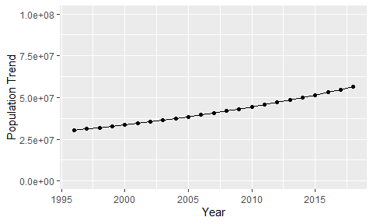

Political Stability Trend

# Population growth trend

The plot shows the population growth rate trend of the country.

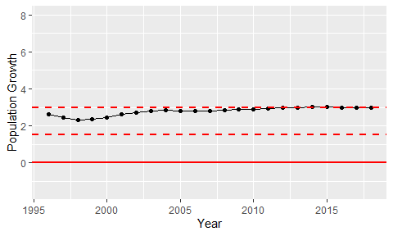

Population Growth Trend